**Supplementary Methods**

*Demographic analysis*

To optimize the models we fit during the analysis, we used a variation on dadi_pipeline, the sequential step-down parameter permutation approach described by Portik et al. (2017) [1]. Unlike this method however, we set the starting parameters for each sequential run via weighting the parameters from each run in the previous iteration by the relative AIC score of that iteration, such that all but the worst runs contribute in some degree to the starting parameters for the next step. The number of runs and iterations per step are listed in Table S3. Individual optimization runs were killed if they took longer than 48hrs to complete, since these runs tended to take far longer to finish and often included integration errors due to extremely small population sizes. Most runs completed in under 48hrs and are included in the results, save for the founder_asym_growth_pop_2 model, for which only a handful completed due (likely due to very small optimal population sizes in Hawaii). The number of runs completed for each model as well as the minimum, mean, and the standard deviation of both the AIC and log(likelihood) scores for each model at each step are shown in Table S4. Graphic depictions for each of the models for that for which one was not included in the main text are available from the dadi_pipeline GitHub repository (https://github.com/dportik/dadi_pipeline/blob/master/Two_Population_Pipeline/Models_2D.pdf). The models represent those depicted here as of August 13th, 2021.

To extract meaningful parameter units from the results, we assumed 0.3 years per generation and used the per-base mutation rate of 8.4x10-9­ reported from Drosophila melanogaster [2]. These values match those used by Zhan et al. (2014) [3]. Using a potentially more realistic generation time of 7 generations per year resulted in more recent divergence times, and using the slower mutation rate reported for the more closely related Heliconius melpomene of 2.9x10-9 [4] resulted in larger effective size estimates and more distant divergence times, for a net result of slightly more distant divergence times and larger effective sizes. Overall, the results did not differ qualitatively to any substantial degree. In order to determine the length of the considered genomic region, we multiplied the total number of bases sequenced after quality filtering (but not SNP p-value filtering so as to count non-polymorphic sites) by the ratio of SNPs in the final allele frequency spectrum to the total number of called SNPs.

**Supplementary References**

1. Portik DM, Leaché AD, Rivera D, Barej MF, Burger M, Hirschfeld M, Rödel M-O, Blackburn DC, Fujita MK. 2017 Evaluating mechanisms of diversification in a Guineo-Congolian tropical forest frog using demographic model selection. *Mol. Ecol.* **26**, 5245–5263. (doi:10.1111/mec.14266)
2. Haag-Liautard C, Dorris M, Maside X, Macaskill S, Halligan DL, Charlesworth B, Keightley PD. 2007 Direct estimation of per nucleotide and genomic deleterious mutation rates in Drosophila. *Nature* **445**, 82–85. (doi:10.1038/nature05388)
3. Zhan S *et al.* 2014 The genetics of monarch butterfly migration and warning colouration. *Nature* **514**, 317.
4. Keightley PD, Pinharanda A, Ness RW, Simpson F, Dasmahapatra KK, Mallet J, Davey JW, Jiggins CD. 2015 Estimation of the spontaneous mutation rate in Heliconius melpomene. *Mol. Biol. Evol.* **32**, 239–243. (doi:10.1093/molbev/msu302)

**Supplementary Tables:**

|  |  |  |  |
| --- | --- | --- | --- |
| **Population** | **Sampling Location** | **Sampling Year(s)** | **# Sequenced** |
| **North America** | Eastern North America (Mexican overwintering sites) | 2016 | 45 |
| Western North American (California overwintering sites) | 2015 | 40 |
| **Hawaii** | Maui | 2016 | 8 |
| Oahu | 2016 | 4 |
| **Mariana Islands** | Guam | 2015 | 24 |
| Rota | 2015 | 20 |
| Saipan | 2015 | 4 |
| **Fiji** | Viti Levu | 2009 | 5 |
| **Samoa** | Upolu | 2006, 2007, 2016 | 31 |
| **New Caledonia** | Grand Terre | 1991, 2006, 2010 | 18 |
| **Australia** | Queensland | 2016 | 44 |
| Victoria | 2016 | 4 |
| New South Wales | 2016 | 6 |
| **New Zealand** | North Island | 2007, 2011 | 6 |
| **Norfolk Island** | Norfolk Island | 2016 | 16 |
| **Total:** | | | **281** |
| **Table S1** – Sampling locations and year for monarchs included in sequencing design | | | |

|  |  |  |  |  |  |  |  |  |
| --- | --- | --- | --- | --- | --- | --- | --- | --- |
| **Population** | **GUA** | **HAW** | **NAM** | **NSW** | **QLD** | **ROT** | **SAI** | **VIC** |
| **GUA** |  | 0.2649 | 0.264 | 0.3546 | 0.3258 | 0.3018 | 0.3039 | 0.3885 |
| **HAW** | 0.001 |  | 0.1 | 0.1288 | 0.1426 | 0.1985 | 0.2411 | 0.1083 |
| **NAM** | 0.001 | 0.001 |  | 0.1824 | 0.1874 | 0.2218 | 0.2703 | 0.1758 |
| **NSW** | 0.001 | 0.002 | 0.001 |  | 0.011 | 0.2862 | 0.3698 | -0.0393 |
| **QLD** | 0.001 | 0.001 | 0.001 | 0.2248 |  | 0.2702 | 0.3366 | 0.0186 |
| **ROT** | 0.001 | 0.001 | 0.001 | 0.001 | 0.001 |  | 0.3627 | 0.3024 |
| **SAI** | 0.001 | 0.001 | 0.001 | 0.001 | 0.001 | 0.001 |  | 0.4227 |
| **VIC** | 0.001 | 0.028 | 0.003 | 0.8112 | 0.1708 | 0.001 | 0.001 |  |
| **Table S2 -** Average pairwise FST across all sites for each pair of populations. FST above the diagonal, p-value from 1,000 permutations below. | | | | | | | | |

|  |  |  |  |
| --- | --- | --- | --- |
| **Run** | **Parameter Permutation** | **Number of Runs** | **Number of Optimization Iterations** |
| **1** | 3 | 100 | 30 |
| **2** | 2 | 50 | 50 |
| **3** | 2 | 60 | 50 |
| **4** | 1 | 100 | 100 |
| **Table S3 –** Degree of parameter permutation, number of independent dadi runs, and the number of iterations per run for each of the dadi optimization passes (see Portik et al., 2017). | | | |

Note: Large table, in attached excel file.

**Table S4 –** Number of completed runs as well as the minimum, mean, and standard deviations of AIC and log(likelihood) scores for each model included in the analysis.

**Supplementary Figures**

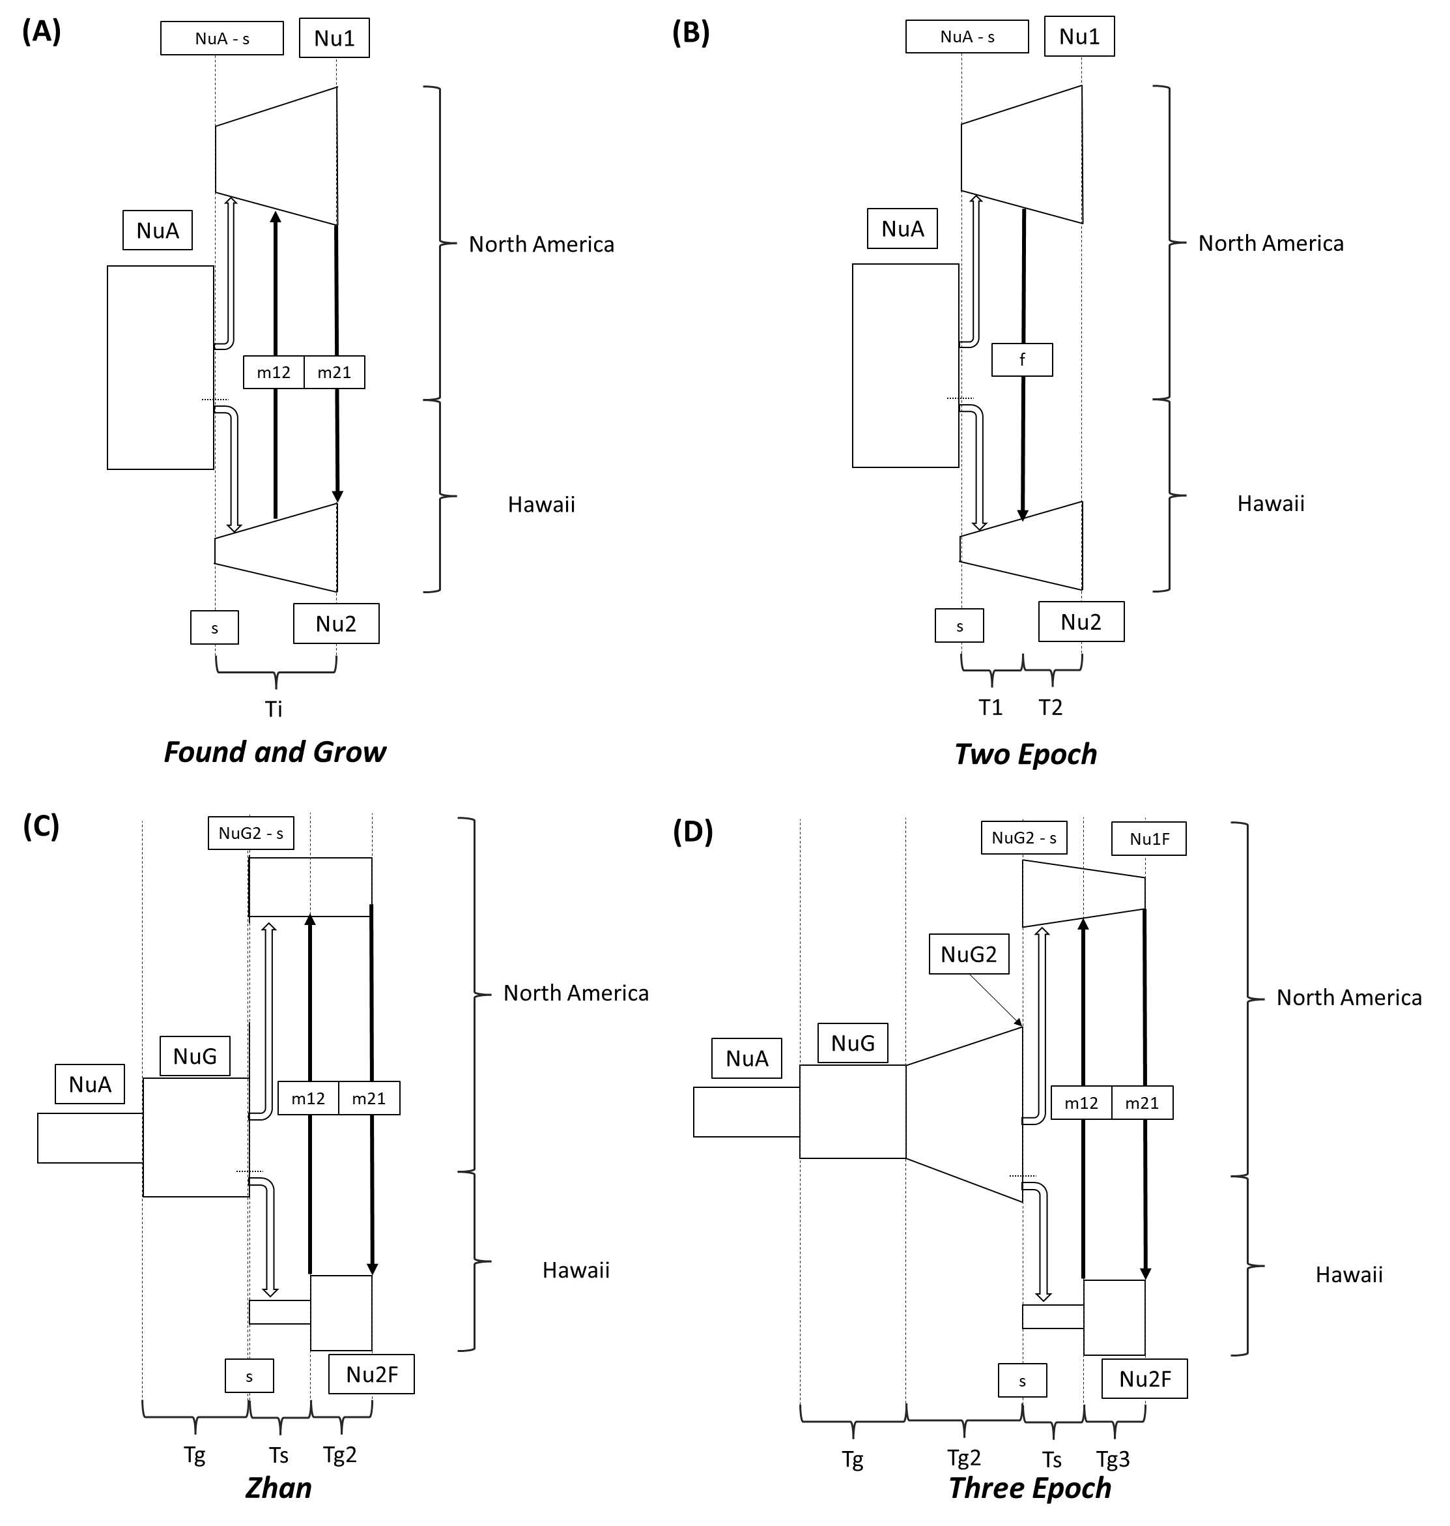

**Figure S1** - Visual depiction of the four best performing models from dadi simulations. Panel (A) shows the less complicated *Found and Grow* model, which assumes a constant ancestral North American population size. In this model, a portion *s* of individuals found the Hawaiian population, with subsequent population growth then allowed until present, with present day population sizes given as Nu1 and Nu2. Migration between populations is allowed in both directions and is shown as m12 (Hawaii > North America) and m21 (North American > Hawaii). Panel (B) shows the *Two Epoch* model, which instead has a one-time admixture event of f individuals. Panel (C) shows the model from *Zhan* et al. (2014), where the ancestral North American population grew from NuA to NuG instantaneously some time before the Hawaiian population was founded, after which the North American population was constant in size but the Hawaiian population had another instantaneous growth period, allowing for a constant migration rate as in the *Found and Grow* model. Panel (D) shows the *Three Epoch* model, which is similar to the *Zhan* model but allows for multiple changes in the size of the ancestral North American population prior to establishment in Hawaii and allows the North American population to change in size after the Hawaiian establishment.

**Figure S2 -** AIC scores for all specified demographic models used in dadi simulations across passes. Note that the three epoch model produced model runs with the lowest single AIC scores, though with substantial variation across runs.

**Figure S3 –** Derived allele frequency spectra (below diagonal) and directionality indices (above diagonal) for each pairwise comparison between each of the six best-sampled populations. Spectra polarized via reference to putative sister taxa *Danaus erippus* and projected to 10 gene copies per population. GUA = Guam, HAW = Hawaii, NAM = North America, NOR = Norfolk Island, QLD = Queensland, ROT = Rota.

**Figure S4 –** The ratio of heterozygous to homozygous sites shown for each individual within the primary sampled populations of interest. As with other metrics of genetic diversity, the ancestral North American population showed the highest levels of heterozygosity, followed by Hawaii and then Australian populations.

**Figure S5 –** Heatmaps of theresiduals for optimized dadi parameter sets for the the *Found and Grow*, *Three Epoch*, *Two Epoch*, and *Zhan* models. Optimized parameters from the runs with the lowest AIC score from each quadrant of the establishment time/founding population size parameter space for each model are shown for comparison (BL: bottom left, BR: bottom right, TL: top left, TR: top right), corresponding to the points marked in red in Figure 2.

**Figure S6 –** ΔK values for NGSadmix runs for each K between 2 and 8.